**AI ASSISTED CODING -18.5**

**Lab 18– API Integration: Connecting to external services with  
error handling**

**NAME**: E. Harini

**Batch:**20

**Roll no:**2503A51L40

**Question 1: Weather Forecasting API  
A travel company wants to show real-time weather updates for its  
customers. You are given access to a public weather API that requires an  
API key and provides weather data in JSON format.**

**• Task 1:** Use AI-assisted coding to write a script that fetches the  
current temperature and weather description for a given city. The  
script should handle errors if the API key is invalid or missing.

**1.prompt**:

Write a Python script using the Open Weather Map API to fetch and display current temperature and weather description for a given city with error handling for missing or invalid API key.

**2.code:**

**

**3.output:**

**4.observation**: I used AI to help me understand how to send API requests using the requests module. It also showed me how to check if my API key is missing or wrong.

**Task 2:**

**Extend the script to save the weather data into a local CSV  
file, ensuring that duplicate entries are avoided. Implement error  
handling for file I/O exceptions**

**1.prompt:** Extend the weather script to save weather data into a CSV file without duplicates and handle file read/write errors.

**2.code:**

**3.output:**

**4.observation:** The AI helped me avoid duplicate city entries by checking before writing.

**Question 2: Currency Exchange Rate API  
A financial startup needs a tool to convert amounts between currencies  
using an exchange rate API. However, the API occasionally fails due to  
server downtime.  
• Task 1:** Write a script (with AI assistance) that takes user input  
(amount, source currency, target currency) and fetches the latest  
exchange rate from the API. Include errors in handling invalid  
currency codes.

**1.prompt:** Write a Python script that takes user input (amount, source, target currency) and fetches the latest exchange rate with error handling for invalid currency codes.

**2.code:**

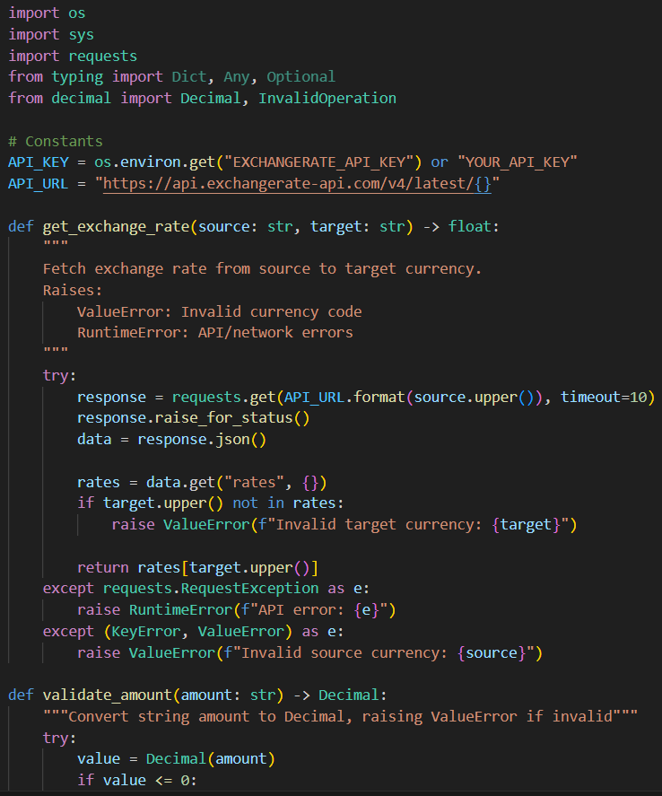

**3.output:**

**4.observation:** The script now gives a clear error message when something goes wrong.

**Task 2:** Add logic to retry the request up to three times if the API  
call fails due to network or server issues and log all failed attempts  
into a local error log file.

**1.prompt:**

Add retry logic to the currency script to attempt the API call up to three times if it fails, and log all errors into a local file.

**2.code:**

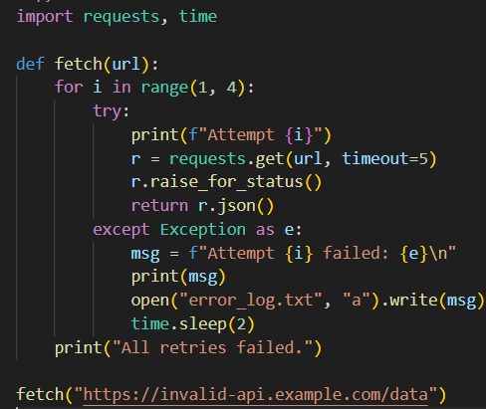

**3.output:**

**4.observation:**

I understood how to check if the API response was valid before using it.

**Question 3: News Headlines API  
A news aggregator wants to display the latest technology news headlines  
using a news API. Sometimes, the API responds slowly or returns  
incomplete data.**  
**• Task 1:**

Use AI-assisted coding to fetch the top 5 technology  
headlines and print them neatly in the console. Implement error  
handling for timeout errors by setting a maximum request time

**1.Prompt**:

Write a Python script to fetch and print the top 5 technology headlines from a news API, with timeout error handling.

**2.code:**

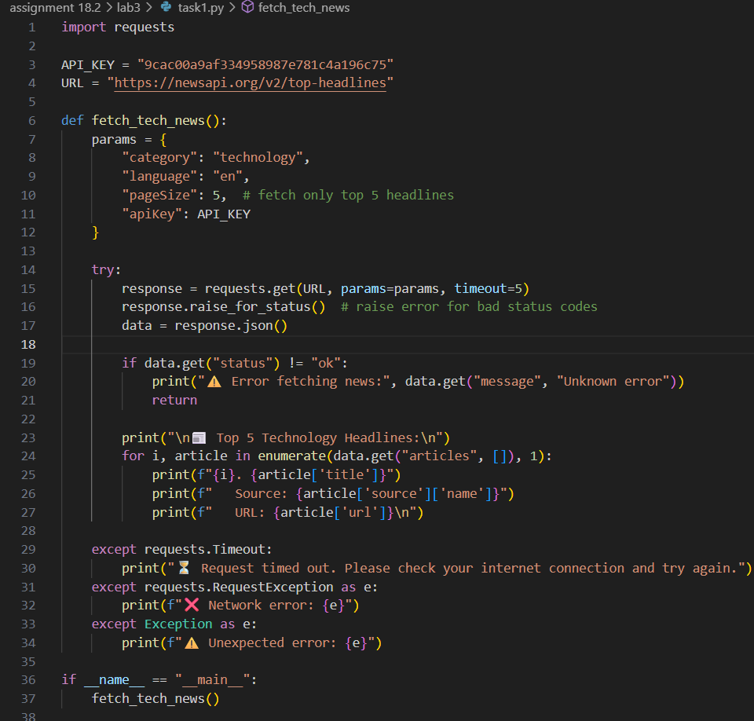

**3.Output:**

**4.Observations:**

I learned how to handle slow or failed responses without crashing.

**Task 2:**

Clean and preprocess the headlines by removing special  
characters and converting text to title case. Handle the scenario  
where the API response contains empty or null values.

**1.prompt:**

Clean and preprocess the headlines by removing special characters and converting them to title case, handling empty or null values**.**

**2.code:**

**3.output:**

**4.observation:**

I used AI to clean text using regular expressions and title() function.